Day-4 EC2 Instance
How to create an EC2 Instance.
Step-1
- Open and login to the AWS console.
- Search EC2 service in AWS.
- Click on that Lunch Instance Button.
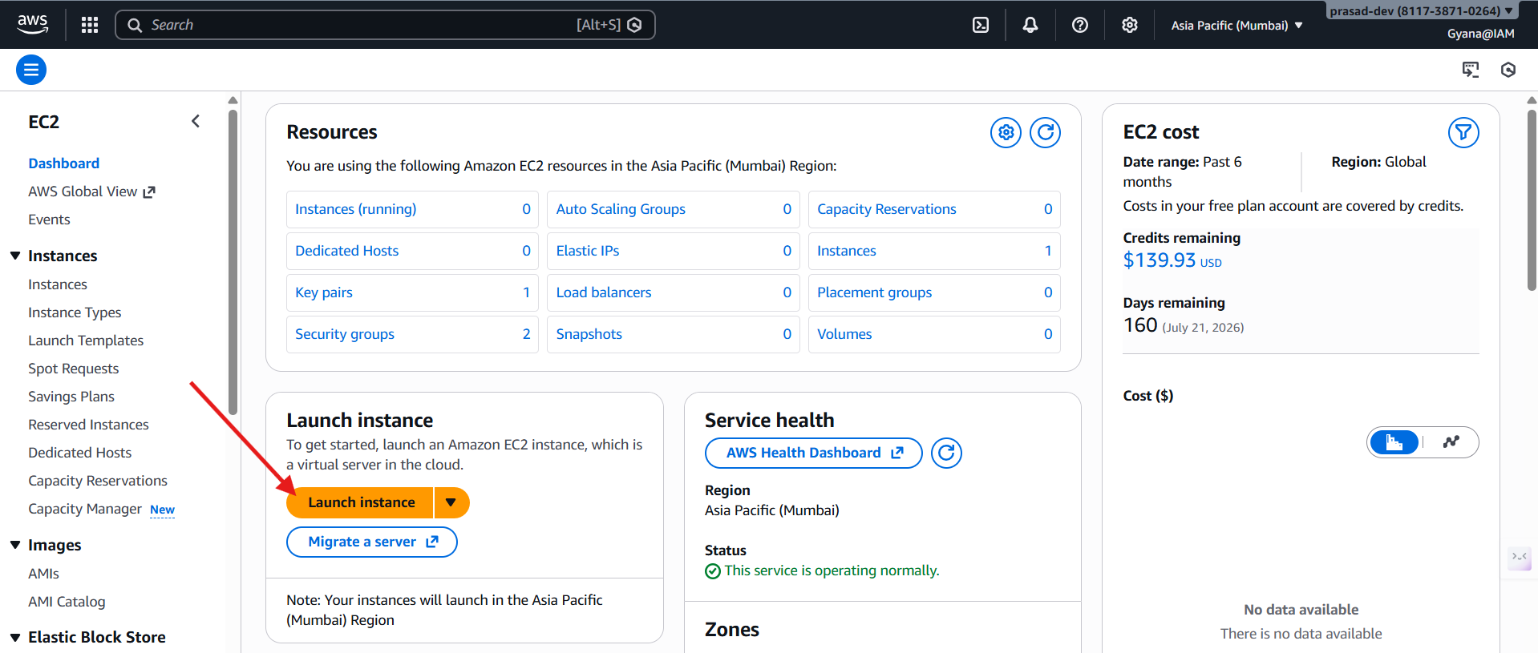
- Give an unique Instance name.
- An select an AMI(Amazon Machine Image) provided by the AWS and select the free tire.
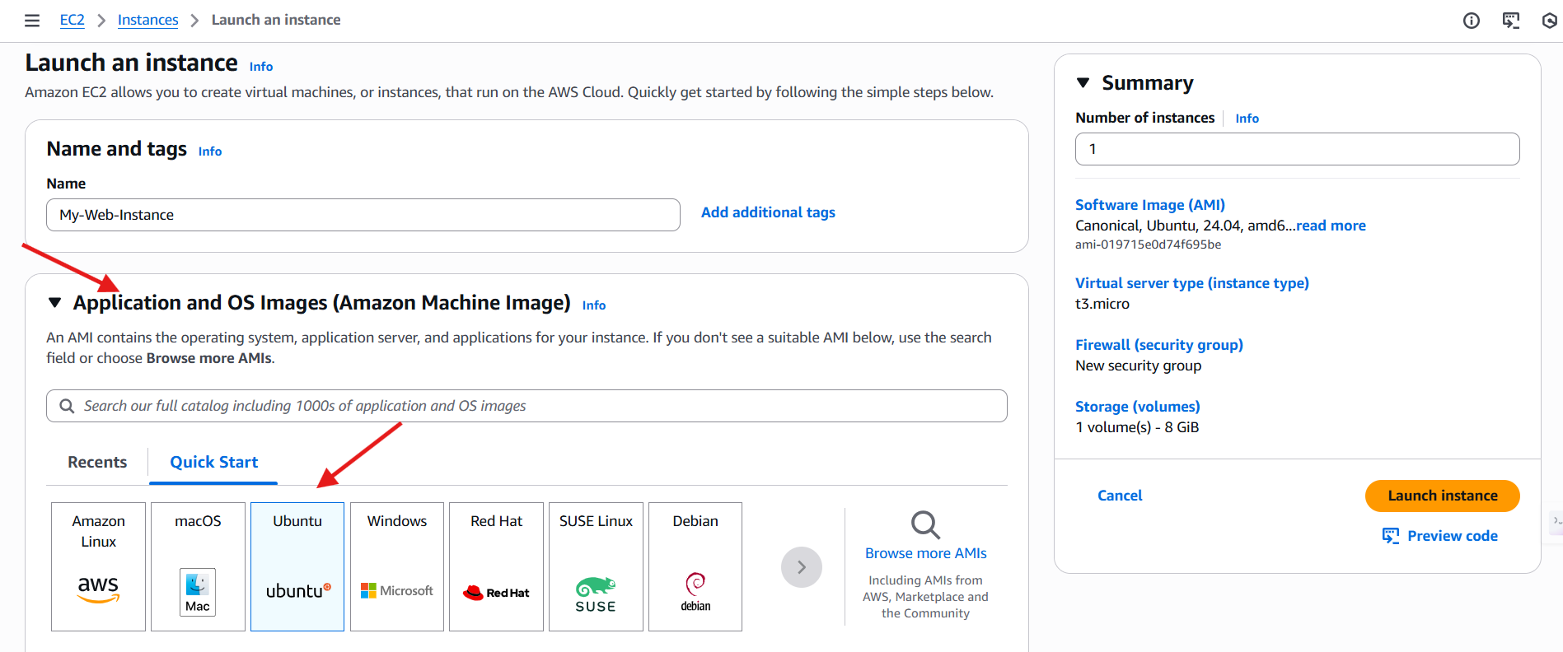
- Now choose Key Pair if don’t have a key pair then create it or else use the existing key pair.
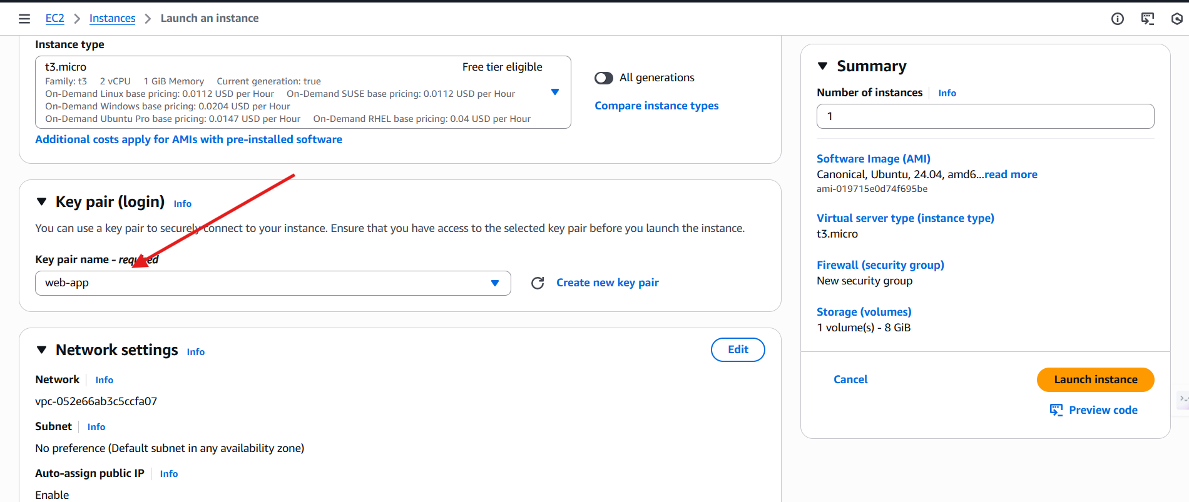
- Now leave all the settings default now and hit the Lunch Instance Button to lunch the EC2 Instance.
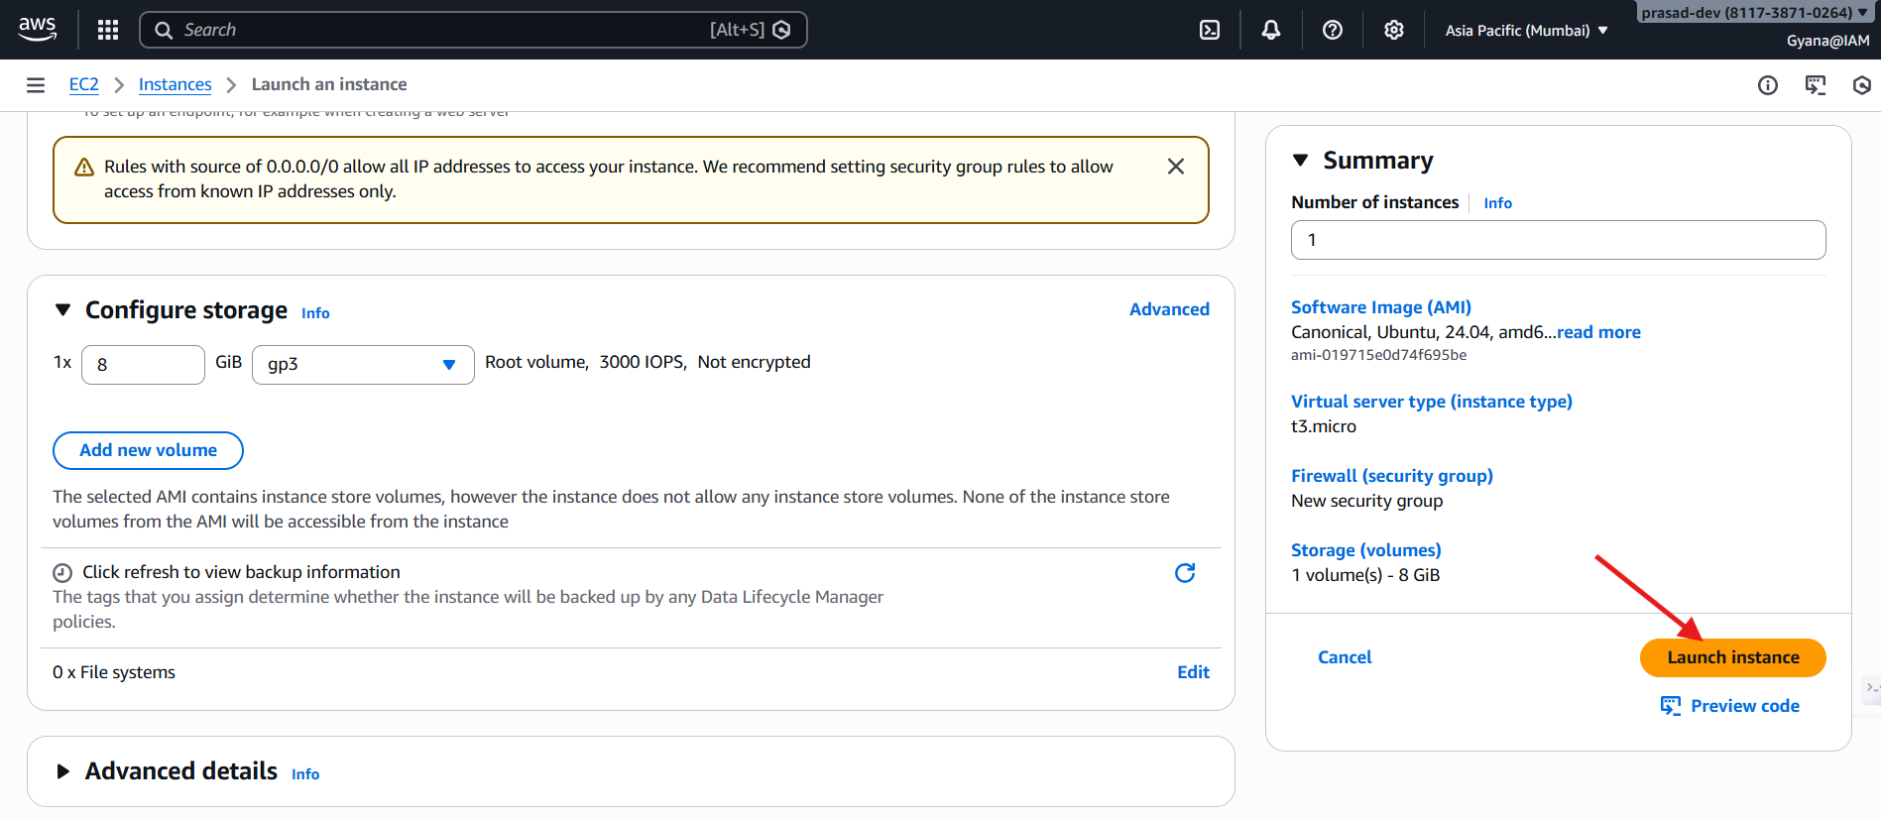
- EC2 Instance name called My-Web-Instance got created and lunched.
Step-2
How to create an own AMI.
- Select the EC2 virtual machine and navigate to the Action button.
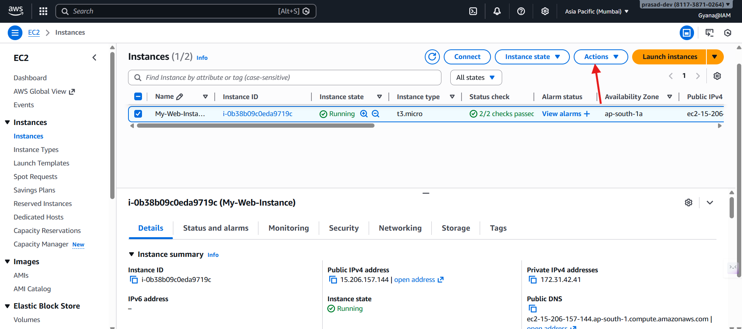
- Select the Image and Template option.
- Now click Create image option to create an AMI.
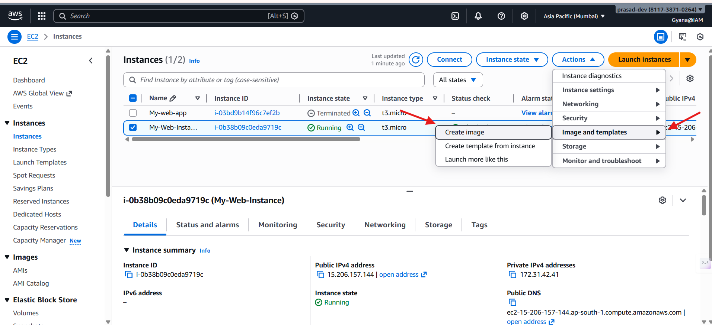
- Provide the Image name .
- Provide the machine name.
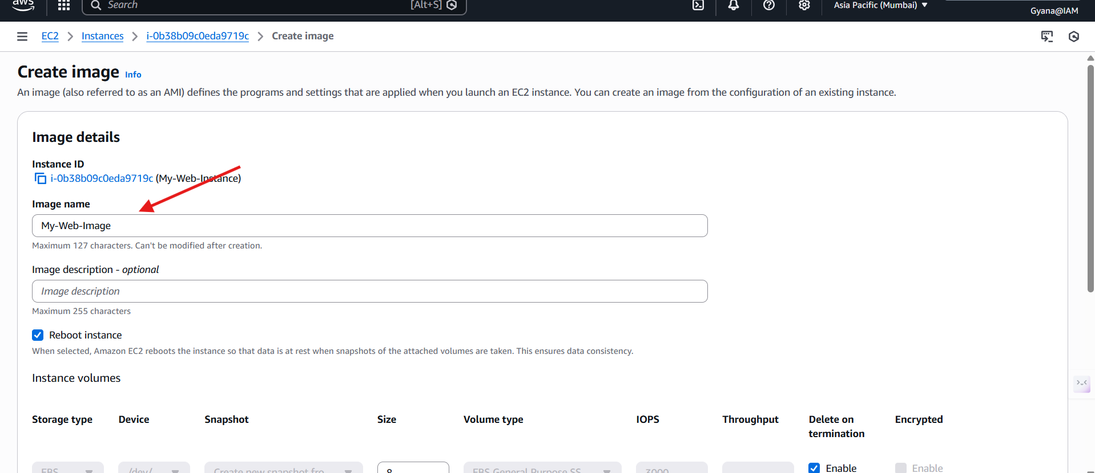
- Click the Create Image button and a AMI will be created.
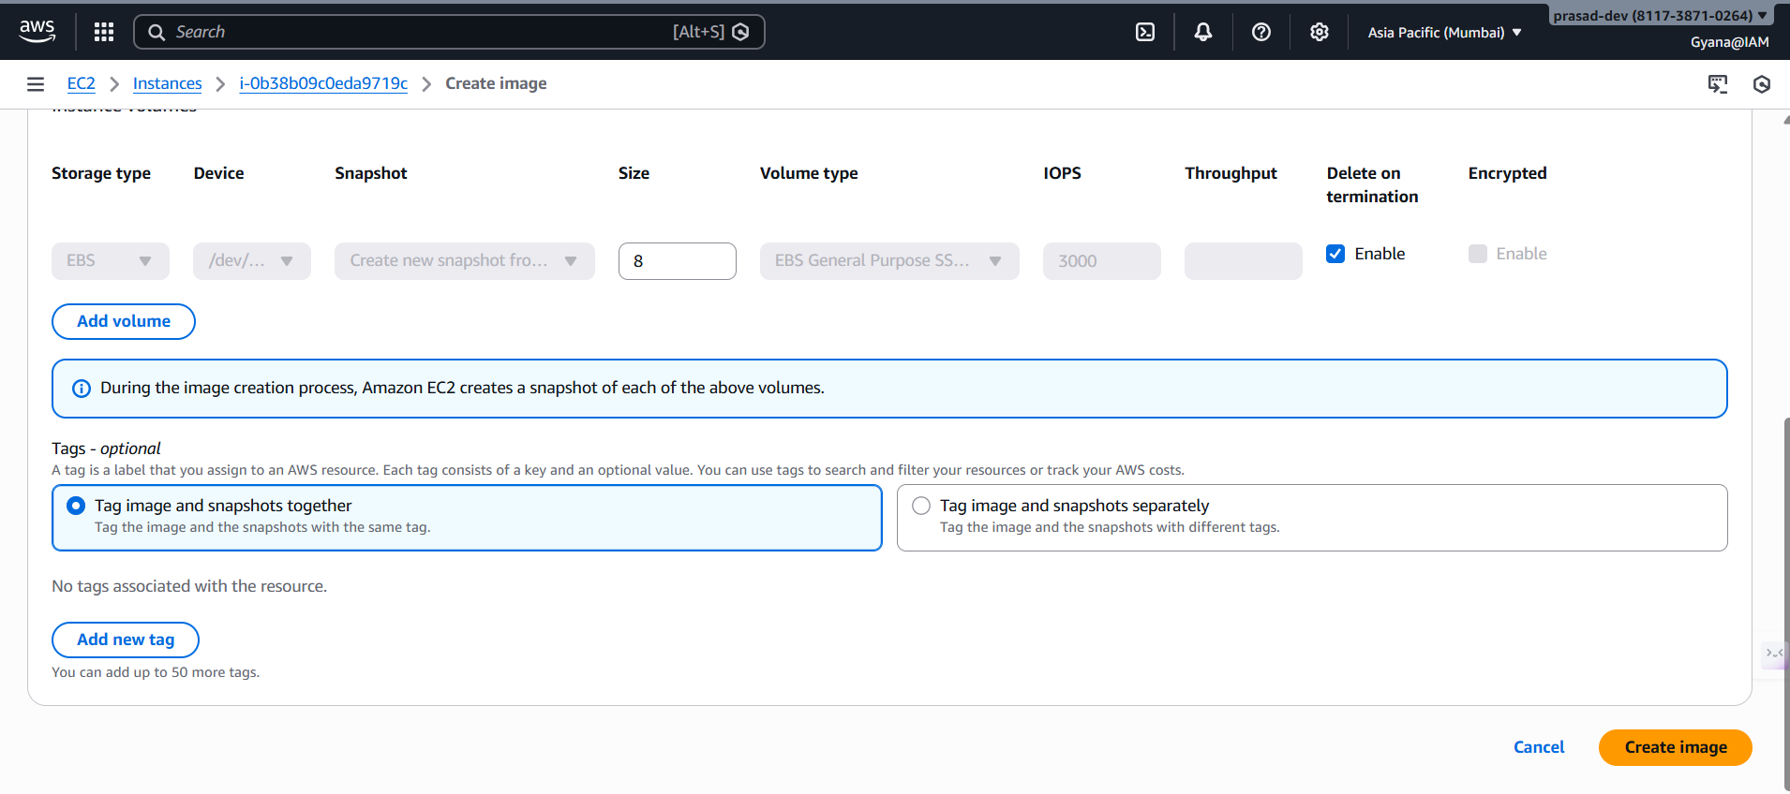
- Go to the AMI section and check the AMI got created.
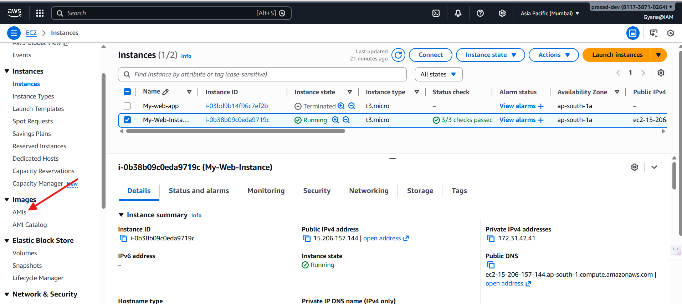
- Check the AMI name My-Web-Image has created successfully.
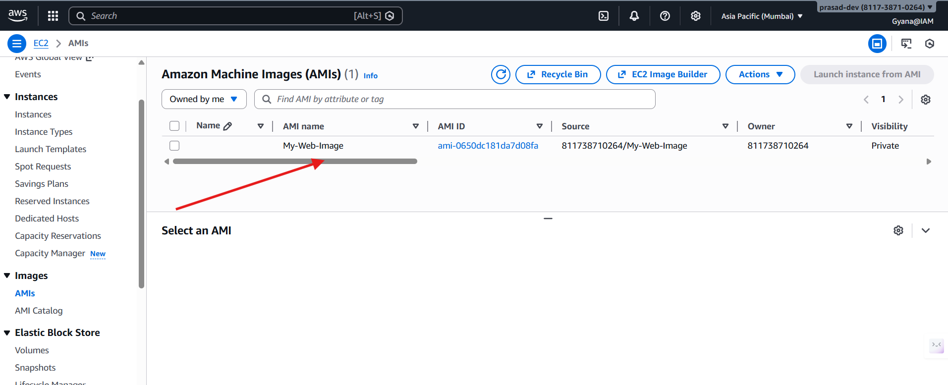
- Now I am lunching an EC2 using My-Web-Image
- To check my AMI click on Browse more AMI option
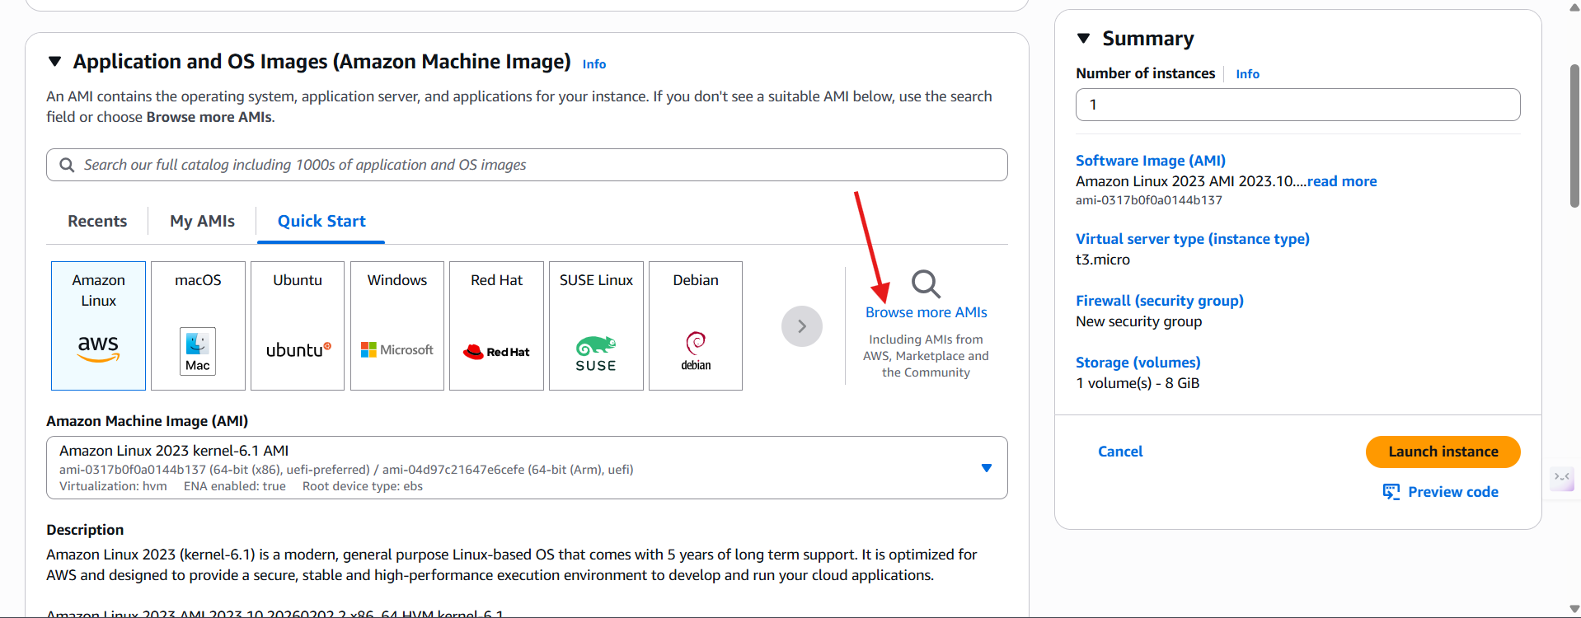
- Now can check my AMI named as My-Web-Image is there inside My AMIs section.
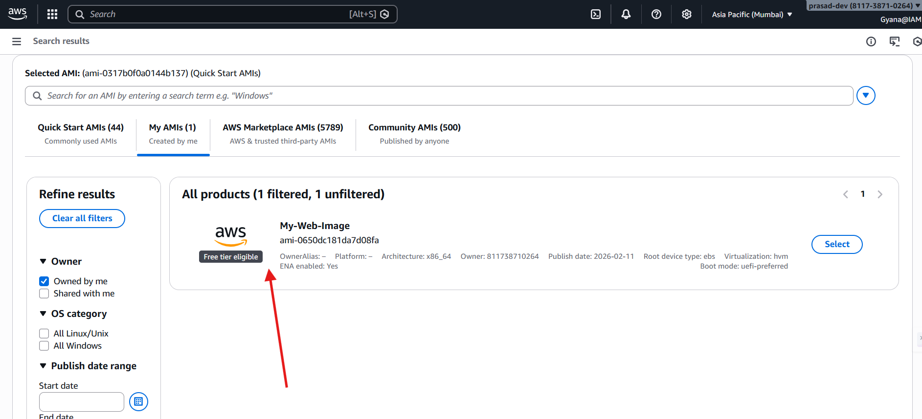
- Now can see the AMI My-Web-Image I have selected is ready to create an EC2 Instance now.
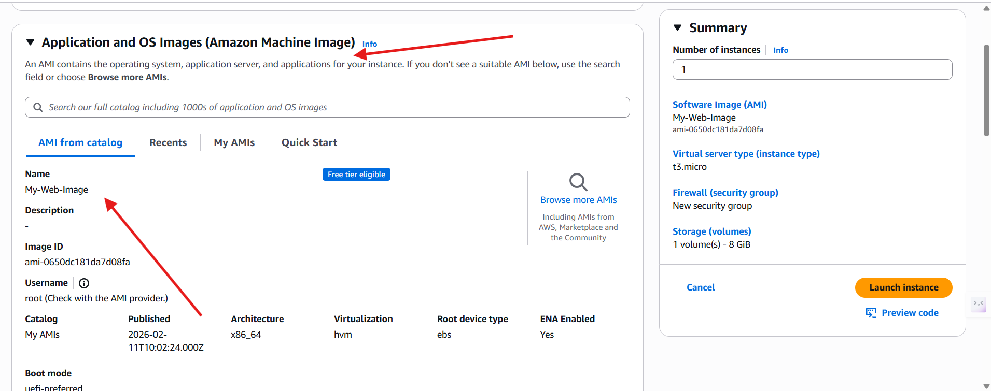
- After selecting and creating all the data and dependencies inside my AMI will be reflect to this new EC2 Instance.

